PROJECT REPORT

ON

### “INDIA‘S AGRICULTURE CROP PRODUCTION ANALYSIS (1997-2021)”

BASED ON THE COURSE

### FUNDAMENTALS OF DATA ANALYTICS WITH TABLEAU - SMARTBRIDGE

SUBMITTED TO

### NAAN MUDHALVAN – SMART INTERNZ DATA ANALYTICS UPSKILL PROGRAMMING



FUNDAMENTALS OF DATA ANALYTICS WITH TABLEAU - SMARTBRIDGE

# INTRODUCTION

#### OVERVIEW

This report delves into the captivating realm of India's agricultural cultivation, providing a comprehensive visual exploration of key aspects and trends in the agricultural sector. Through the visual representations, readers can

gain valuable insights into crop production, seasonal variations, regional distribution, and overall production trends. These visualizations enable intuitive analysis,

allowing stakeholders to uncover patterns, identify areas of growth or concern, and make data-driven decisions.

#### PURPOSE

By harnessing the power of Tableau, this report not only presents the data in a visually appealing manner but also provides an interactive experience for readers to explore the intricacies of India's agricultural cultivation. To Extract the Insights from the data and put the data in the form of visualizations, Dashboards and Story we employed Tableau tool.

## PROBLEM DEFINITION AND DESIGNS THINKING

#### PROBLEM DEFINITION:-

Analysing India's Agricultural Crop Production over a 25 year period (1995-2021) will help the users to assess the long term trends and patterns in crop production. Based on

the analysis, recommendations can be provided for the policymakers and the stakeholders to improve agricultural practices, allocate resources effectively and to enhance food security. Such an analysis would pave way to develop more predictive models to forecast crop production trends in the future. This project also aims to help policymaker and stakeholders to address challenges and opportunities in India's agricultural sector during

the specific period.

* 1. EMPATHY MAP

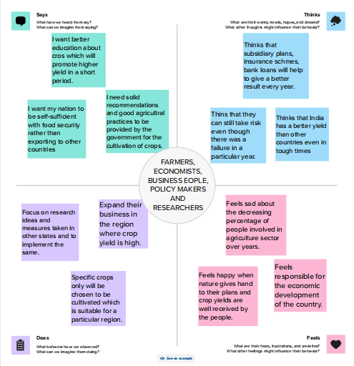

* 1. IDEATION AND BRAINSTROMING MAP

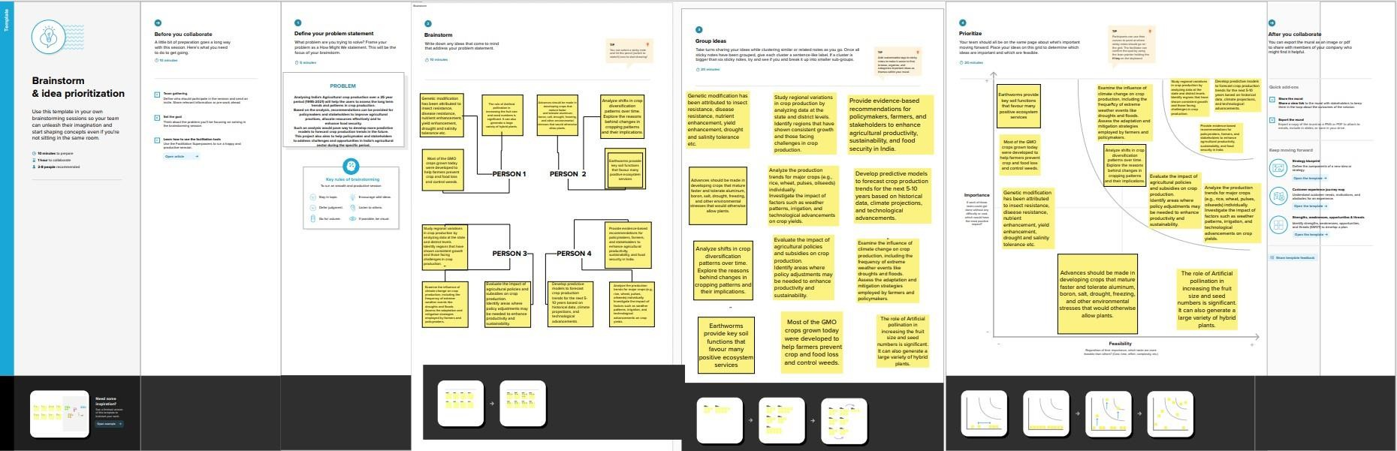

# RESULT

## RESULTS OF DASHBOARD VISUALIZATION

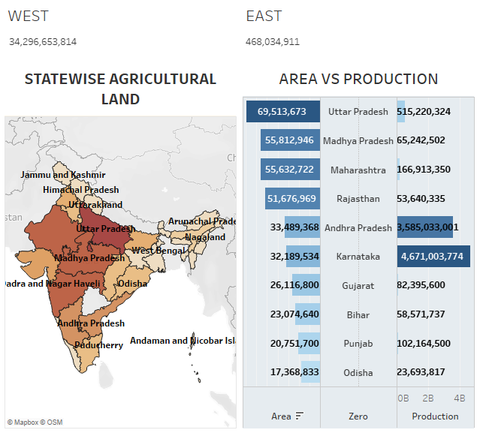

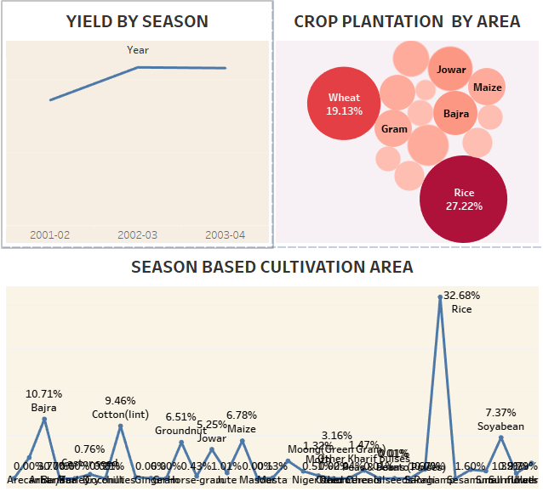

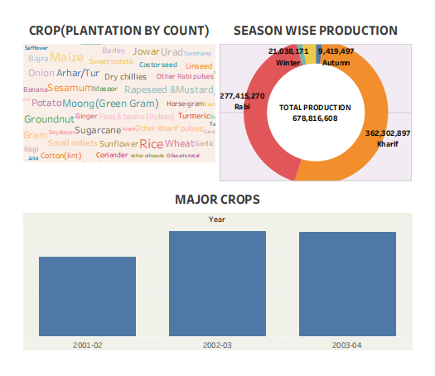

RESULTS OF STORY VISUALIZATION:-

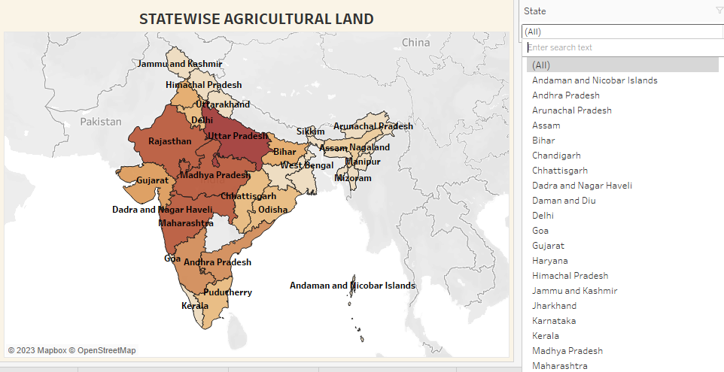

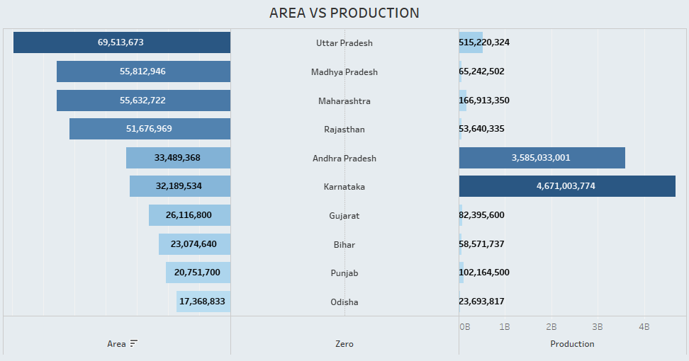

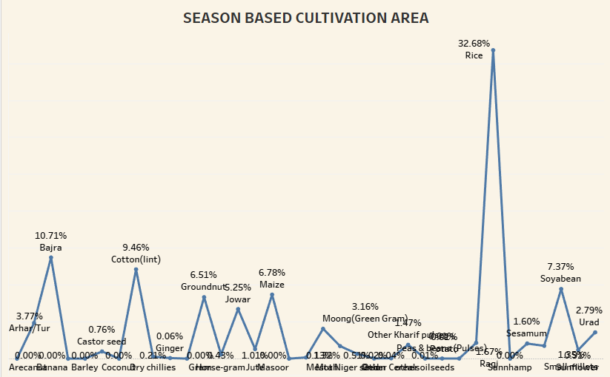

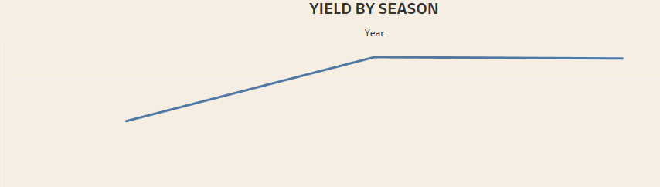

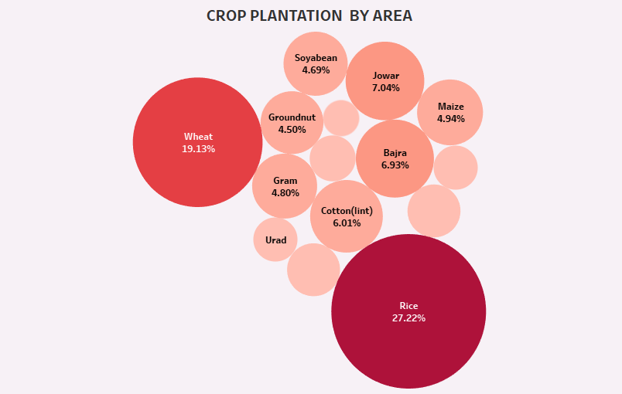

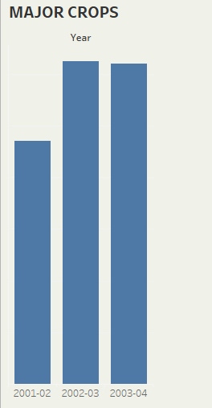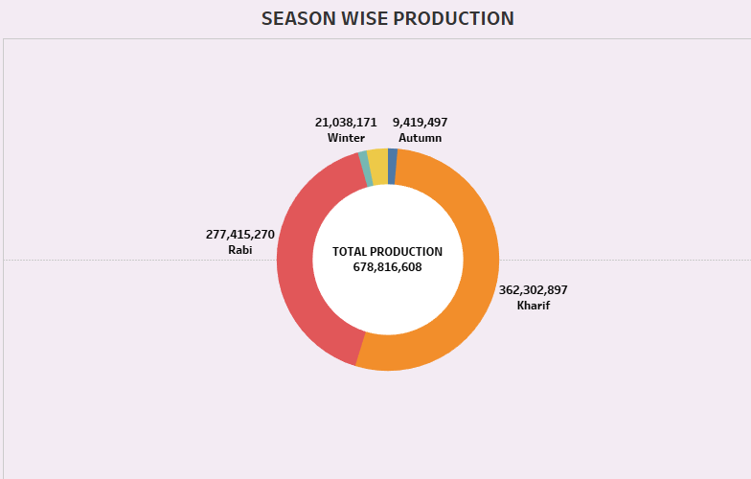

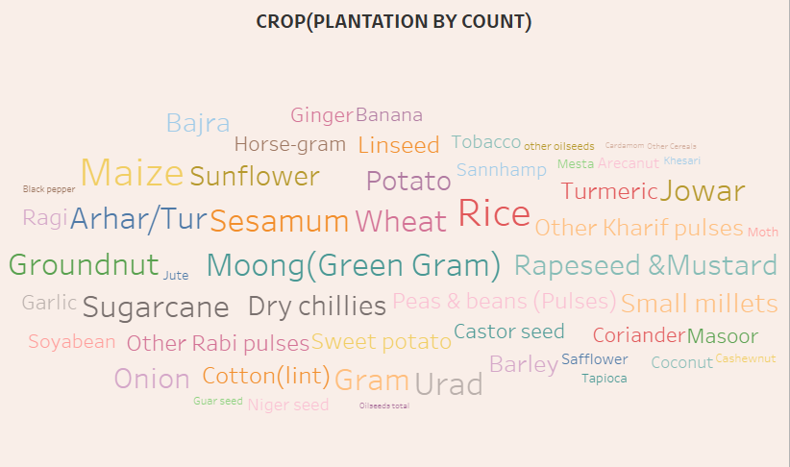

## ADVANTAGES AND DISADVANTAGES

* 1. ADVANTAGES
     + Food Security: Understanding agricultural production helps ensure a stable food supply, addressing the needs of India's large

population.

* + - Economic Impact: Agricultural analysis contributes to the economy, as agriculture is a significant sector providing employment and raw materials for various industries.
    - Policy Formulation: Data analysis aids policymakers in formulating effective agricultural policies, ensuring sustainable growth and

development in the sector.

* + - Resource Allocation: Identifying trends in production helps optimize resource allocation, ensuring efficient use of land, water, and other agricultural inputs.
    - Global Competitiveness: Analysis can highlight areas of

improvement, making Indian agriculture more competitive in the global market and fostering international trade.

* 1. DISADVANTAGES
     + Climate Change Impact: Rapid changes in climate patterns can disrupt traditional agricultural practices, making it challenging to predict and analyze production trends accurately.
     + Market Volatility: Fluctuations in market conditions, influenced by factors like global demand and geopolitical events, can make it difficult to plan based solely on historical production data.
     + Dependency on Monsoons: India's agriculture is heavily reliant on monsoons, and unpredictable weather patterns can lead to

uncertainties in production, affecting the reliability of analysis.

## APPLICATIONS

Crop production analysis in India has multifaceted applications ranging from on-the-ground farming decisions to policy formulation at the national level, contributing to the overall development and sustainability of the agriculture sector.

* Research and Development: Analysis of crop production data provides valuable insights for research and development

efforts, helping to improve crop varieties, pest resistance, and overall agricultural productivity.

* Food Security: Understanding crop production helps in

ensuring food security by identifying potential shortfalls or surpluses and taking proactive measures to address them.

* Financial Planning: Farmers can make informed financial

decisions based on crop production analysis, optimizing their investments and securing a more stable income.

* Government Subsidy Allocation: Governments can use production analysis to allocate subsidies effectively,

targeting support to areas and crops that need it the most for sustainable agricultural development.

## CONCLUSION

The Tableau visualization spanning 1997 to 2021 of India's agriculture crop production is a powerful tool for unraveling the

complexities of the sector. It serves as a comprehensive resource for evidence-based decision-making, fostering sustainable

practices, and steering the agricultural landscape towards resilience and growth.

It allows for targeted analysis, helping to understand the factors influencing the production of specific crops, reveal seasonal patterns in crop production, plays a crucial role in tailoring policies to address the unique challenges faced by different parts of the country.

Visualizing the timeline alongside key policy changes allows for an examination of their impact on agricultural production. This

insight is invaluable for policymakers assessing the effectiveness of various interventions.

## FUTURE SCOPE

### Predictive Analytics for Precision Agriculture:

Utilizing machine learning algorithms within Tableau, future

scopes could involve predictive analytics for precision agriculture.

By training models on historical data from 1997 to 2021, the visualization can offer insights into potential future trends.

### Dynamic Dashboard for Real-time Monitoring:

The future of agriculture crop production analysis lies in real- time monitoring and decision-making. Enhancing the Tableau

visualization into a dynamic dashboard allows stakeholders to

monitor ongoing trends, incorporating the latest data seamlessly.

Integrating IoT (Internet of Things) devices and sensors can

provide real-time updates on weather conditions, soil moisture, and other critical variables

THANK YOU